paper
title
here

Author(s) Affiliation(s)
(Full postal address for correspondence author;
brief address for other authors)
*Corresponding author: Fax: +xx xx xxxx xxxx Email: xxxx@xxxx.xxxx.xx

Abstract (12 pt)
Put Abstract text here. This guide has been prepared for authors of papers to be presented at the ICOME’17 International Conference on Materials & Energy to be held in Tianjin, on July 06-09, 2017. It has been written in accordance with these requirements. Authors are requested to follow these guide-lines to achieve uniformity in the presentation of the Proceedings.. (11 pt)
Nomenclature
Put nomenclature here. The editors of all the major heat transfer journals have adopted a common list of symbols. All authors should use these symbols for papers submitted for this symposium. Symbols in the list must not be included in the nomenclature for an individual paper. Only symbols peculiar to an individual paper should be included in a nomenclature list that should be placed immediately following the Abstract. The symbol list can be found in the Journal of Heat Transfer, Vol 121, No. 4, pp. 770-773, November 1999, or on the web site CommonSymbols.doc..

introduction (i.e., a FIRST LEVEL HEADING)
Put introduction here. The typing area of all pages should be 170 x 240 mm, whichever size of paper is used, with equal margins on left and right. Each page should be completely filled with typing and/or diagrams (except perhaps the last page). The total length of a paper, including all figures, tables and references if any, should be no more than 6 pages for oral contributed papers and no more than 3 pages for poster contributed papers. Put introduction here. Put introduction here. Put introduction here.

Put body of the paper here. For reference use ASME format, i.e., number in square bracket [1]. Put body of the paper here. Put body of the paper here. Put body of the paper here. Put body of the paper here. Put body of the paper here. Put body of the paper here. Put body of the paper here. Put body of the paper here. Put body of the paper here. Put body of the paper here. Put body of the paper here. Put body of the paper here. Put body of the paper here. Put body of the paper here. Put body of the paper here. Put body of the paper here. Put body of the paper here. Put body of the paper here. Put body of the paper here. Put body of the paper here. Put body of the paper here. Put body of the paper here. Put body of the paper here. Put body of the paper here. Put body of the paper here. Put body of the paper here. Put body of the paper here. Put body of the paper here. Put body of the paper here. Put body of the paper here. Put body of the paper here. Put body of the paper here. Put body of the paper here. Put body of the paper here. Put body

Second level heading: The text must follow directly, The text must follow directly, The text must follow directly, The text must follow directly, The text must follow directly, The text must follow directly, The text must follow directly, The text must follow directly, The text must follow directly, The text must follow directly,.

Third level heading: The text must follow directly, The text must follow directly, The text must follow directly, The text must follow directly, The text must follow directly, The text must follow directly, The text must follow directly,.

ANALYSIS AND MODELLING

The word “Table” should be capitalized and centred with the table number above the table. On the next line, the table caption should be typed single spaced and centred, with the first letter of all main words in capitals. Use horizontal rules above and below to separate title from column heads, ranks within column heads, column heads from table body, and table body from table footnotes or source. For example:

Table 1
Comparison between Numerical and Experiment

Controlling  Number | Numerical  (W/m²) |  | Experimental  (W/m²)
 | Top | Bottom | Top | Bottom
10² | 23.47 | 46.94 | 21.30 | 48.10
10³ | 198.23 | 396.46 | 200.20 | 404.70

RESULTS AND DISCUSSION

Conclusions

KEYWORDS
In a covering letter, please supply six to eight keywords which apply to your paper. This will assist in the preparation of an index for the Proceedings.

NON-ENGLISH SPEAKING AUTHORS
Authors from non-English speaking countries are requested to find persons who are competent in English and familiar with the scientific language who can edit their manuscripts before submission. Reviewers must not be relied upon to make corrections of English expression, spelling, etc.
Acknowledgments
Put acknowledgments here.
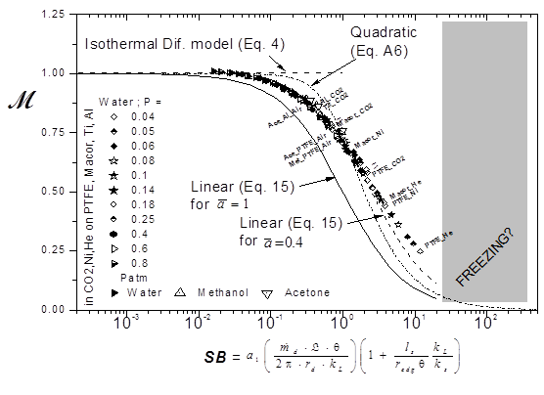Figure 1
evaporation rates as a function of the dimensionless number SB. (Times New Roman 11 pts)

References
Put references here.
1. Kim, S. F, and Low, F, 1997, Liquid Film Cooling at High Temperature, J. Film Cooling, 122, pp. 21-26.
2. Schlichting, H., 1979, Boundary-Layer Theory, 7th edition, McGraw-Hill, New York.

